DBS Lab : 3&4

***Task 1:******Display the name and job title for everyone that’s in the emp table.***

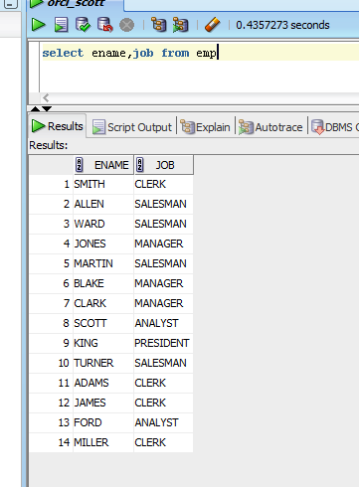

**Task 2:** *Display the employee name, job, and salary for everyone that*

*does not belong to the job title “CLERK”.*

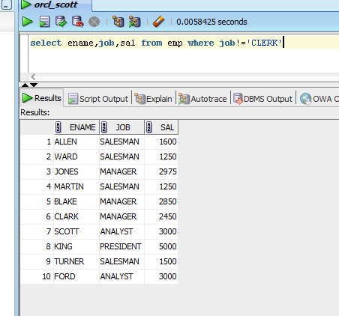

**Task 3:** *Display all columns for everyone whose dept no: equals 108.*

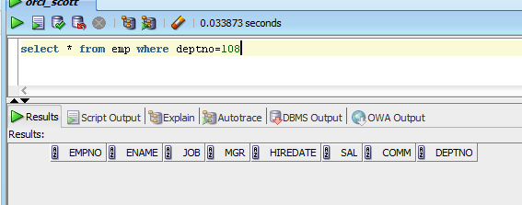

**Task 4:** *Select all the data of employees who are being managed by the*

*manager having id equals to 7698.*

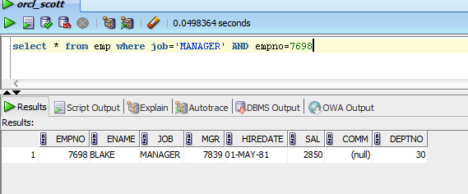

**Task 5:** *Write a query that displays employee name, employee number,**salary and department number for all the employee having salary**less than 1500 and job title is clerk.*

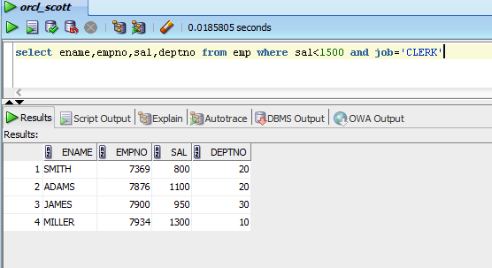

***TASK 6:*** *Write a query to display all the employees whose name starts**with letter B.*

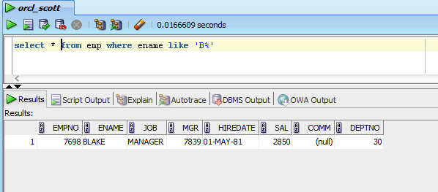

***TASK 7:*** *Retrieve the ename, salary and job titles of all the employees**who are working either as DIRIGENTE or DOTTORANDO.*

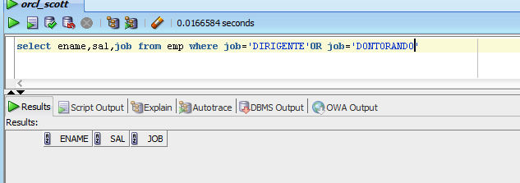

***TASK 8:*** *Display the name of all employees who have both an a and an e**in their name.*

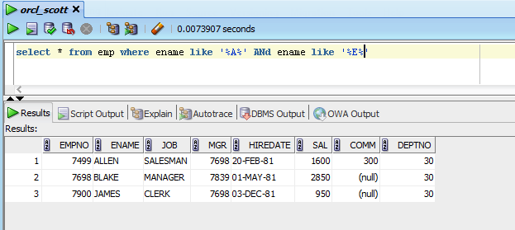

***TASK 9:*** *Select all the data of employees that work in department department 30 or department 60.*

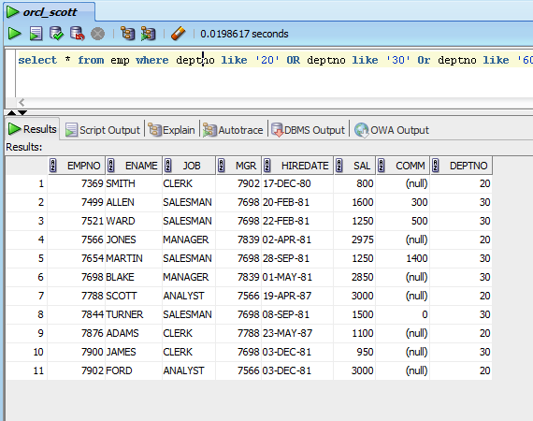

***TASK 10:*** *Create a query that renames the ename column as emp_name.*

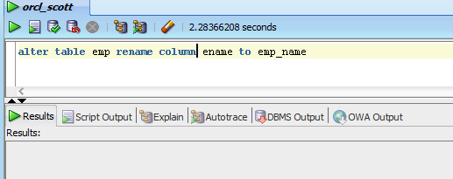

***TASK 11:*** *Create a query to display unique employee names from the emp table.*

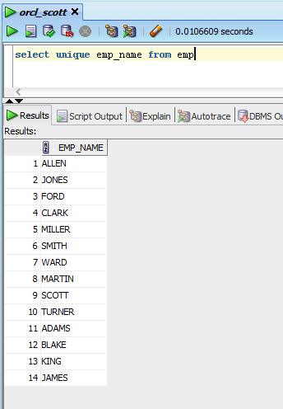

***TASK 12:*** *Create a query to display ename and job title as single column**having column name as “Information”( Hint: Use concatenation operator)*

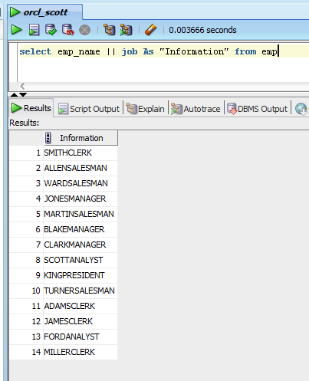

***TASK 13:*** *Retrieve the record of an employee whose name begins with M**and whose salary is between 500 and 1000.*

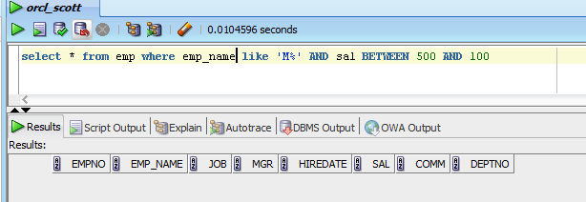

***TASK 14:*** *Retrieve all the records where the ename does not start with N**and salary is greater than or equals to 500 and job does not equal**to TECNICO.*

